 |  |  | 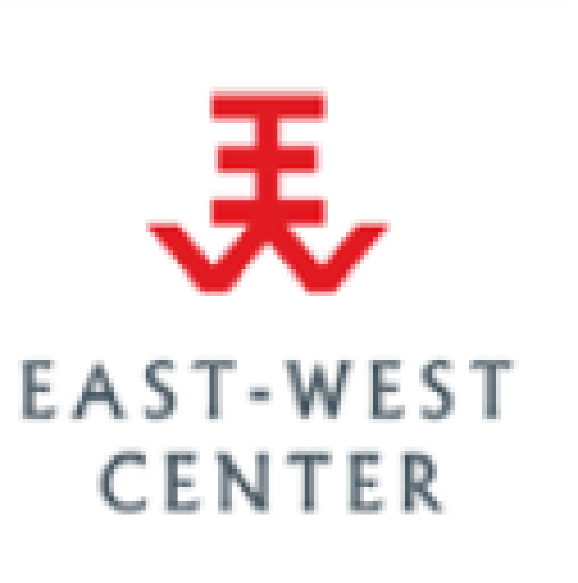 |  | 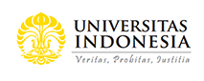 | Universitas Gadjah Mada

Asia-Pacific Regional Virtual Meeting
Using National Transfer Accounts (NTA)
for Population Ageing Policy Advancement
Thursday 7th, 2021, 1000-1230 Jakarta Time
For Policy Planners and Government Officials
Background
Following three regional workshops on the National Transfer Accounts (NTA) in Asia hosted by UNFPA Asia and Pacific Regional Office together with HelpAge International and the East-West Center held in 2014 (Bangkok), 2015 (Pattaya), and 2017 (Chiang Mai), this virtual meeting is sponsored and co-hosted by UNFPA Asia and Pacific Regional Office together with the Asian Population Association, the East-West Center, HelpAge International, Universitas Gadjah Mada, Universitas Indonesia, and Ministry of National Development Planning for Population and Labor (BAPPENAS), Republic of Indonesia. Over a decade, academics, national officials, experts, and policy planners in Asia have become acquainted with the NTA methodology. While several countries have produced NTA and used the results to support policy development, some countries have limited experience in applying the NTA measures and results for policy development. This virtual meeting offers an opportunity to update state of the art knowledge of NTA implications for policy development.
Objectives of the Meeting
1. To introduce the generational economy perspective using simplified National Transfer Account evidence to support engagement of policy planners on addressing demographic diversity and dividends, gender and population ageing in the region
2. To have feedback and inputs from policy planners on the usefulness of NTAs for policy development
Participants
Policy planners from over 20 countries in Asia-Pacific who are users of NTA evidence for population ageing policy advancement.
Background Documents
- Ronald Lee and Andrew Mason, 2011. Population Ageing and Generational Economy: A Global Perspective. Edward Elgar, IDRC, 2011
https://ageingasia.org/population-aging-and-generational-economy/

- United Nations, Population Divisions, Department of Economic and Social Affairs, 2013. National Transfer Accounts Manual: Measuring and Analyzing the Generational Economy.
https://ntaccounts.org/doc/repository/NTA%20manual%202013.pdf

- A list of publications on NTA topics can be accessed from below
https://www.ntaccounts.org/web/nta/show/Publications

Agenda
Time | Programme
1000-1015  (15 min) | Opening Remarks  H.E. Pungky Sumadi, Deputy Minister of National Development Planning for Population and Labor (BAPPENAS), Republic of Indonesia  Bjorn Andersson, Director of UNFPA Asia-Pacific Regional Office
1015-1020  (5 min) | A short VDO introducing the National Transfer Accounts  by Office of the National Economic and Social Development Council, the Prime Minister Office of the Royal Thai Government and UNFPA Thailand
1020-1050  (30 min) | Keynote: A Generational Perspective on Aging and Policy in Asia  Chair: Aris Ananta, the Asian Population Association  Speaker: Andrew Mason, the East-West Center and University of Hawaii
1050-1145  (1 hr 15 min) | Round Table Discussion: NTA and Population Aging Policies - Challenges and Opportunities in Asia  Chair: Eduardo Klein, HelpAge International  Panelists:  H.E. Arkhom Termpittayapaisith, Minister of Finance of Thailand (tbc)  H.E. Suahasil Nazara, Vice Minister of Finance, Republic of Indonesia  H.E. Fathimath Niuma, Deputy Minister for National Planning, Housing, and Infrastructure of the Maldives

1145-1200  (15 min) | The United Nations’ contributions and future support to promote utilization of NTA for policy development in Asia-Pacific  Chair: Sabine Henning, Social Development Division, UN ESCAP  Speakers:  Michael Hermann, Population Development Branch, UNFPA New York  Tim Miller, Population Division, UN Department of Economics and Social Affairs
1200-1215  (15 min) | Summary and conclusion  Maliki, BAPPENAS, Indonesia  Anjali Sen, Representative of UNFPA Indonesia

Master of Ceremony: Evita Hanie Pangaribowo, Universitas Gadjah Mada

